1. 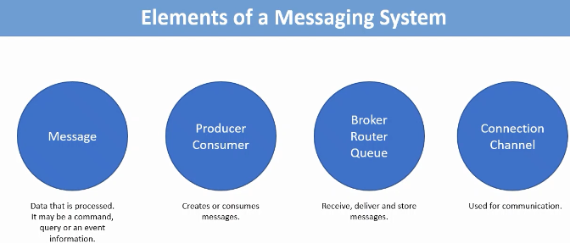
2. 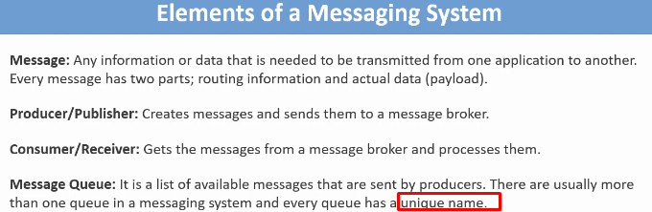
3. 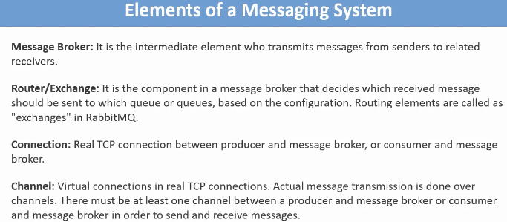
4. **Binding**: The concept binding defines the relationship b/w exchange and queues. The binding definition may contains info like “routing key” and “Header” which are used to filter messages to send a particular queue.  
   A queue can be bound to one or more exchanges.   
   Exchange compares the routing info of the message with the routing configuration in binding and accordingly decides whether it should send the message to the bound queue or not.  
   